# SQL Injection Vulnerability in Project-Online-Shopping-Website

The SQL injection vulnerability exists in the `/delete.php` file, where the following code is present:

```php

include_once("config.php");

$code = ($_POST['product_code']);

$sql = "DELETE FROM products WHERE product_code='".$code."'";

```

User input data is directly concatenated into the SQL statement **without any security processing** and is executed as part of the SQL statement. For example, entering the input `'OR '1'='1` can delete all data in the table.

Because it will be DELETE FROM products WHERE product_code='' OR '1'='1'



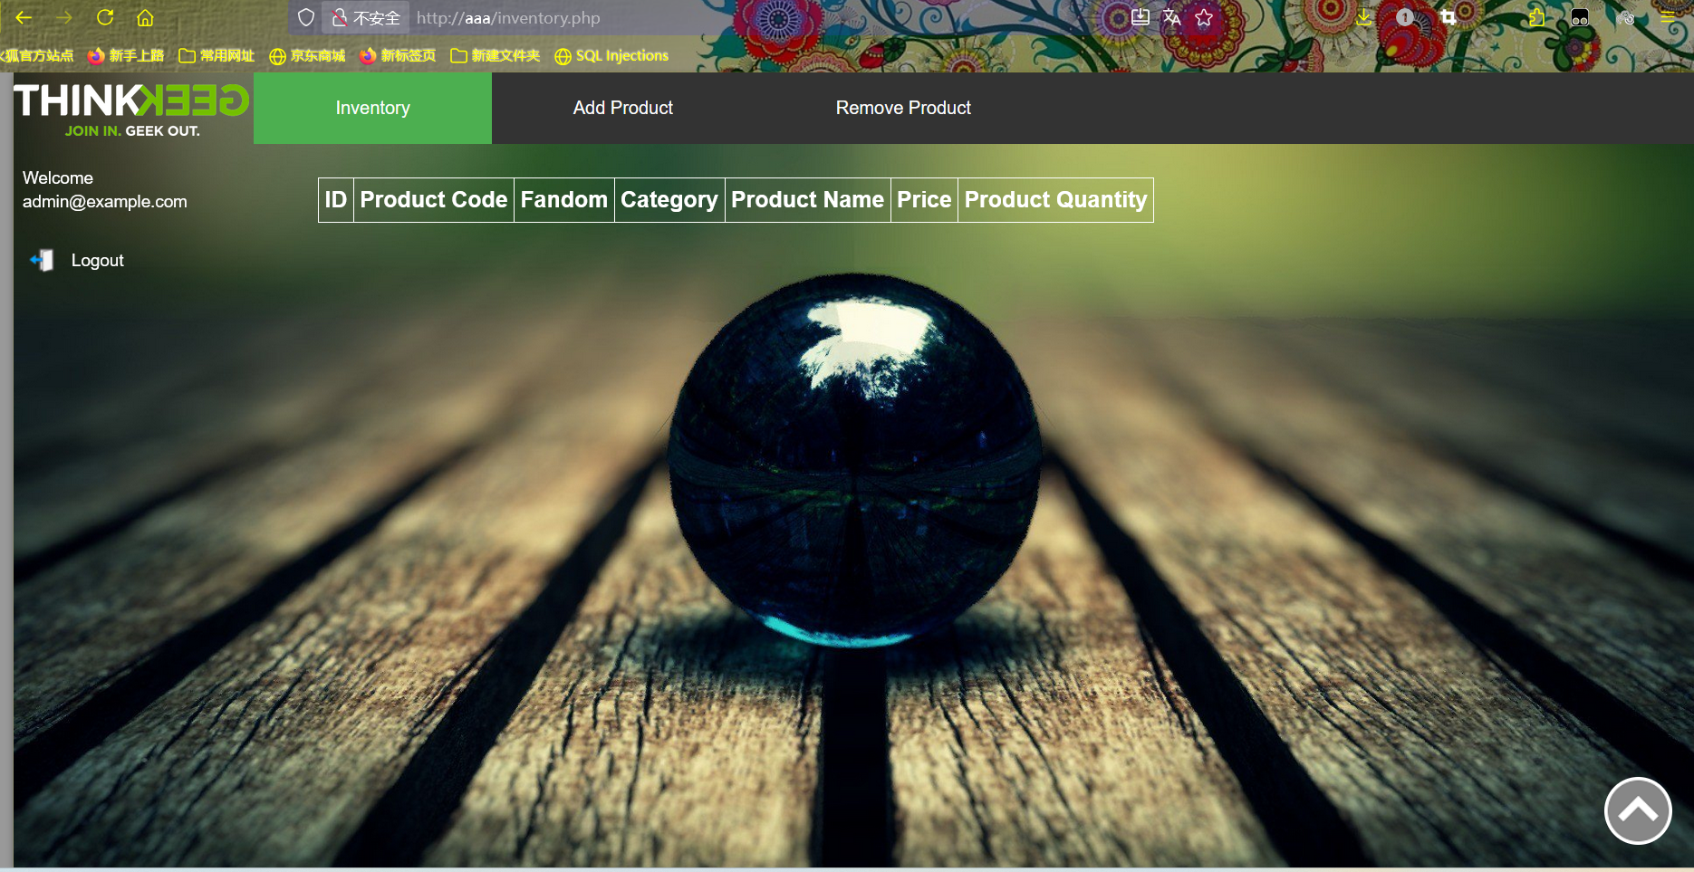

# Project Setup and Vulnerability Reproduction

## 1. Download the Project

Download the project from GitHub:

https://github.com/jimit105/Project-Online-Shopping-Website

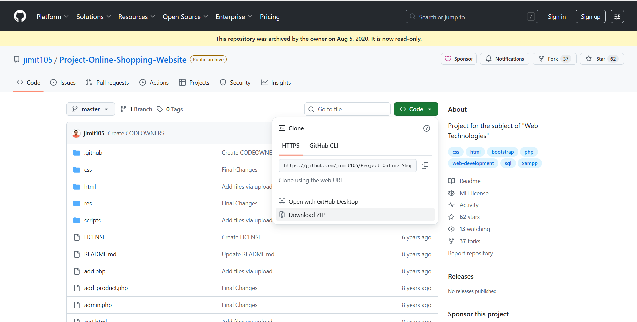

### Repository File Structure (Key Files)

- `add.php`

- `add_product.php`

- `admin.php`

- `config.php`

- `delete.php`

- `remove_product.php`

- `signup.php`

- `log.php`

- `pro.php`

## 2. Start the Service

Open PHPStudy, and start the **Apache** and **MySQL** services.

## 3. Place the Project

Copy the project folder to `D:\phpstudy_pro\WWW\`, ensuring the project root directory is directly accessible.  Create the website root directory in XP as D:/phpstudy_pro/WWW/Project-Online-Shopping-Website-master/Project-Online-Shopping-Website-master

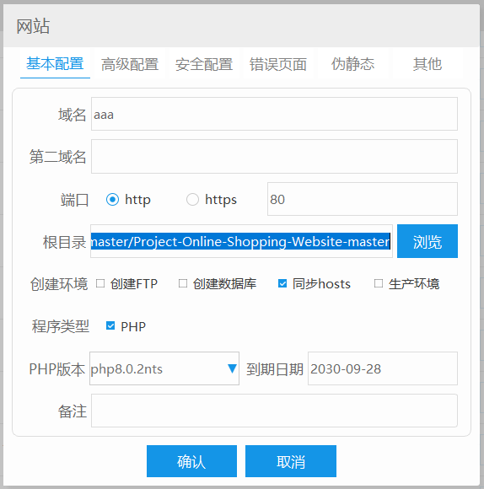

## 4. Import Database Files

In MySQL, create a database named `online`, then import `products.sql` and `users.sql` into the `online` database.

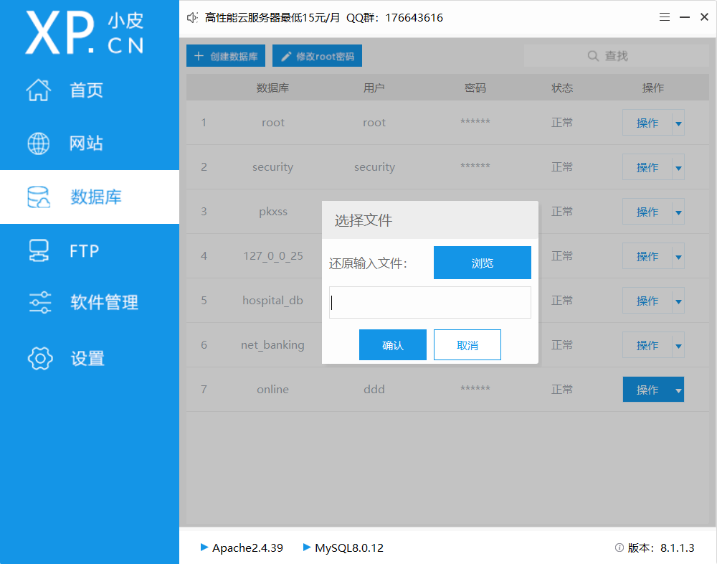

## 5. Configure Database Connection

Open `config.php` and modify the database parameters to match your `online` database credentials:

```php

<?php

$currency = '&#8377;'; // Currency Character or code

$db_username = 'ddd';   // Your database username

$db_password = '123456';// Your database password

$db_name = 'online';    // Database name

$db_host = 'localhost'; // Database host

$shipping_cost = 1.50;  // Shipping cost

// List your Taxes percent here

$taxes = array(

    'VAT' => 12,

    'Service Tax' => 5

);

// Connect to MySQL

$mysqli = new mysqli(hostname: $db_host, username: $db_username, password: $db_password, database: $db_name);

if ($mysqli->connect_error) {

    die(Error:(' . $mysqli->connect_errno . ') ' . $mysqli->connect_error);

}

?>

```

Additionally, update the database credentials in `signup.php`, `log.php`, and `pro.php` to ensure consistency.

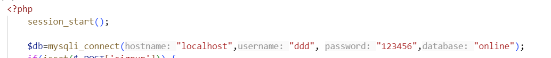

## 6. Access the Website

Open a browser (e.g., on Windows XP) and access the website via the configured domain (e.g., `http://aaa`).

## 7. Log In with the Default Admin Account

- **Email**: admin@example.com

- **Password**: admin (MD5 hash: 21232f297a57a5a743894a0e4a801fc3)

## 8. Modify Redirect Paths (If Necessary)

Adjust the redirect paths in `add.php` and `delete.php` to ensure normal functionality. This step is only required if pages like `/delete.php` cannot be opened or functions fail due to incorrect paths.

add.php

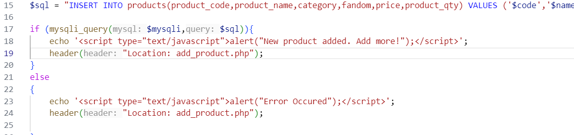

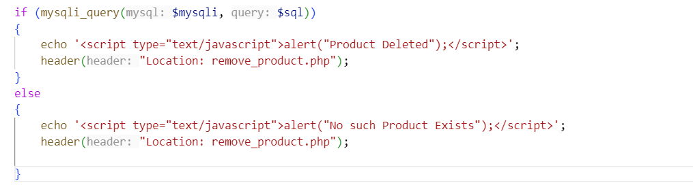

## 9. Test Normal Delete Function

1. Access `/delete.php`; it will redirect to `remove_product.php`.

2. Navigate to the `Inventory` page to view existing products:

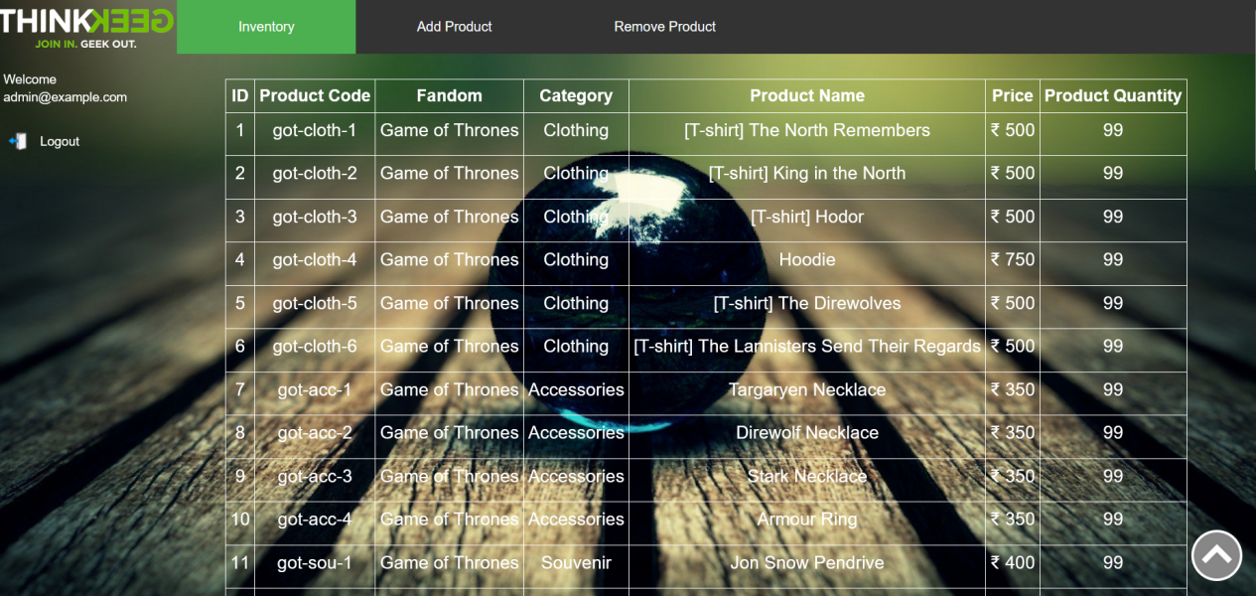

3. Enter a valid product code (`got-cloth-1`) in the "Product Code" field on `remove_product.php`:



4. Confirm the product is deleted successfully. The `Inventory` page will no longer display the deleted product:

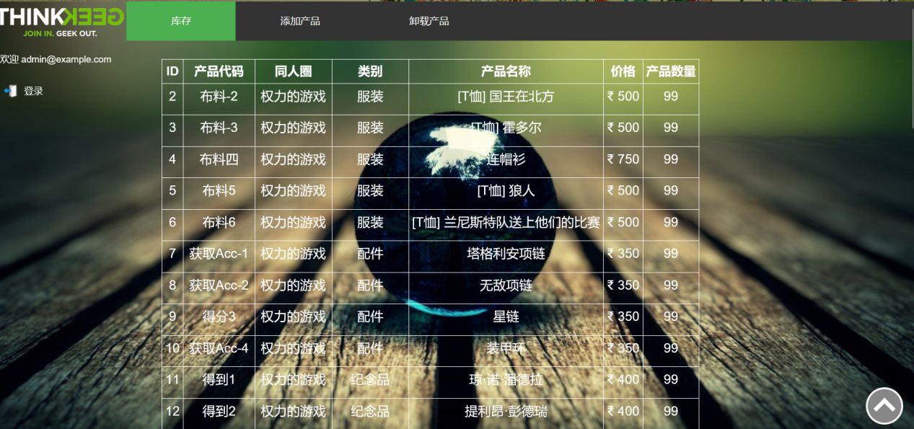

## 10. Verify the SQL Injection Vulnerability

1. On the `remove_product.php` page, enter the malicious input `'OR'1'='1` in the "Product Code" field:



2. Submit the input. Navigate back to the `Inventory` page; all products will be deleted, confirming the existence of the SQL injection vulnerability:

